2. Order Management System

1. Customer table
create table Customer(
customer_id int primary key,
customer_name varchar(50),
email varchar(50),
phone varchar(15),
city varchar(30)
);
INSERT INTO Customer VALUES
(1, 'Ravi', 'ravi@gmail.com', '9876543210', 'Delhi');
INSERT INTO Customer VALUES
(2, 'Aman', 'aman@gmail.com', '9876500001', 'Mumbai');
INSERT INTO Customer VALUES
(3, 'Priya', 'priya@gmail.com', '9876500002', 'Ahmedabad');
INSERT INTO Customer VALUES
(4, 'Neha', 'neha@gmail.com', '9876500003', 'Pune');

2. Product table
create table Product(
product_id int primary key,
product_name varchar(50),
category varchar(30),
price decimal(10,2)
);
INSERT INTO Product VALUES
(101, 'Laptop', 'Electronics', 50000);
INSERT INTO Product VALUES
(102, 'Mobile', 'Electronics', 20000);
INSERT INTO Product VALUES
(103, 'Headphones', 'Accessories', 3000);
INSERT INTO Product VALUES
(104, 'Keyboard', 'Accessories', 1500);

3. Orders table
create table Orders(
order_id int primary key,
customer_id int references Customer(customer_id),
product_id int references Product(product_id),
quantity int,
order_date date,
total_amount decimal(10,2)
);
INSERT INTO Orders VALUES
(1001, 1, 101, 1, TO_DATE('2025-06-29','YYYY-MM-DD'), 50000);
INSERT INTO Orders VALUES
(1002, 2, 102, 1, TO_DATE('2025-06-28','YYYY-MM-DD'), 20000);
INSERT INTO Orders VALUES
(1003, 3, 103, 2, TO_DATE('2025-06-27','YYYY-MM-DD'), 6000);
INSERT INTO Orders VALUES
(1004, 4, 104, 3, TO_DATE('2025-06-26','YYYY-MM-DD'), 4500);
1. Display all customers
select * from Customer
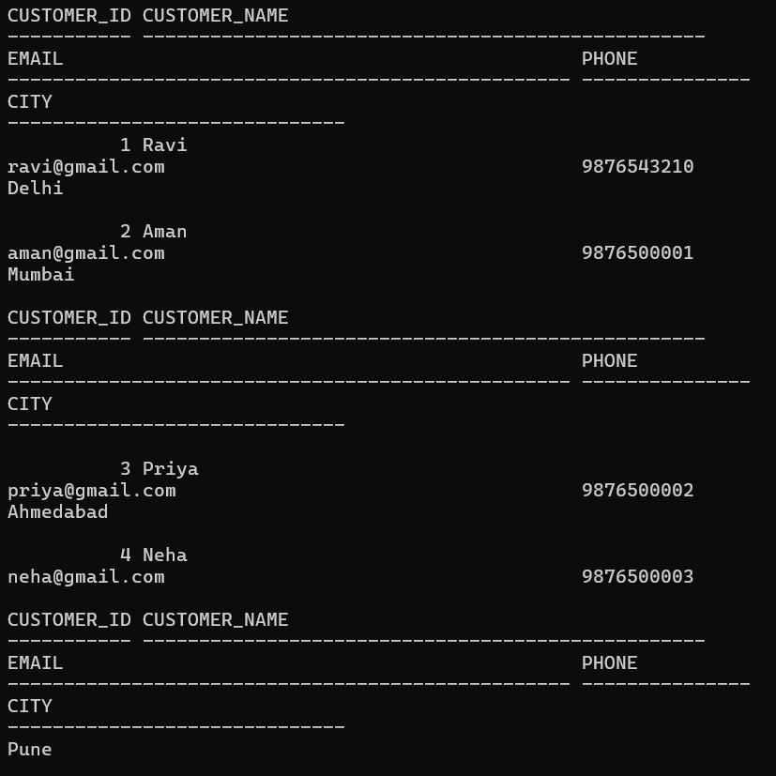

2. display all product names
select product_name from Product;


3. total products purchased by each customer
select customer_id, SUM(quantity) from Orders
GROUP BY customer_id;
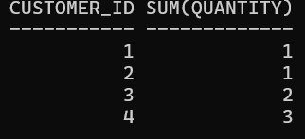

4.Quantity of each product purchased by particular customer
select Customer.customer_name,
Product.product_name,
Orders.quantity from Orders
JOIN Customer
ON Orders.customer_id = Customer.customer_id
JOIN Product
ON Orders.product_id = Product.product_id
WHERE Customer.customer_id = 1;
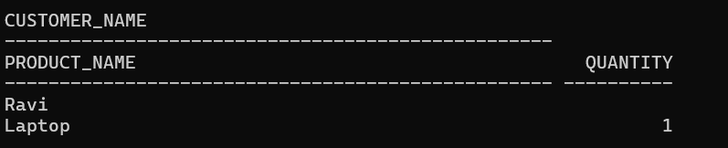

5.Customer invoice showing customer name, product name, quantity, price and total amount
SELECT
Customer.customer_name,
Product.product_name,
Product.price,
Orders.quantity,
Orders.total_amount,
Orders.order_date
FROM Orders
JOIN Customer
ON Orders.customer_id = Customer.customer_id
JOIN Product
ON Orders.product_id = Product.product_id;
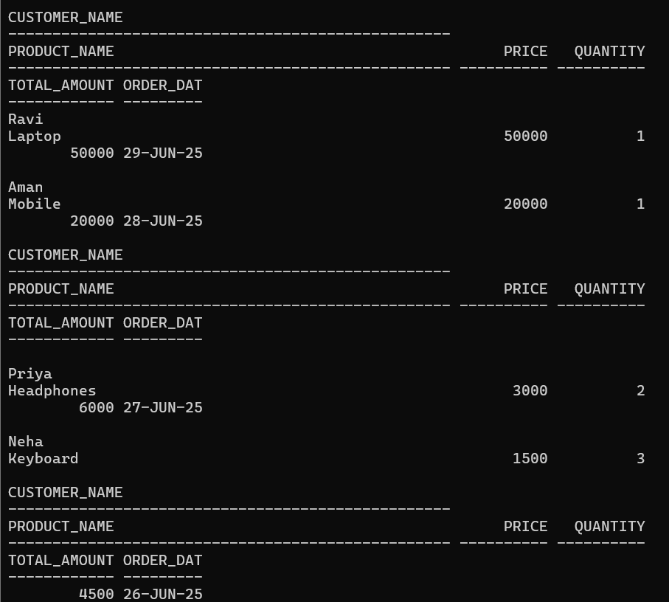

6.Customers who purchased products worth more than 5000.
select customer_id,total_amount
from Orders
where total_amount > 5000;
OR
SELECT
c.name,SUM(o.total_amount)

FROM Orders o
JOIN Customer c
ON o.customer_id = c.customer_id
GROUP BY c.name

HAVING SUM(o.total_amount) > 5000;
